Contents

Introduction 2

Installation and Setup 2

Configuring the Module Installer in OpenEMR: 2

Setting-up Module Installer: 3

Setting Up Modules using the Module Installer: 3

Disabling a Enabled Module: 5

Configuration of Modules: 6

Access Control: 6

Advanced ACL: 7

Using the Advanced Tab: 8

Hook Management: 8

Introduction:

Module installer envisions giving the community the option to install enhancements as compartmentalized code in order to help maintain and manage installations.  Thus enabling contributors to release features as modules which users can opt to use without hindering the basic structure and direction and the common project.

This enables developers to release features without effecting the core structure of the OEMR project and mitigating risks only to their individual installations. This would enable different installations to have multiple solutions on the same installation and implement solutions to real business problems faced by their practices only ie users will have the ability to implement a calendar which has a certain feature or look that is not viable to any other practice.

This gives the community a flavour of multiple solutions; of which some can be eventually be made of the main source code when the project leads have time to complete their testing and review. This is could also lead to vendors allowing third party modules made available to individual users for a price thus increasing the acceptance of the product leading to similar scenario like the app marketplace.

# Installation and Setup

## Configuring the Module Installer in OpenEMR:

The Module installer can be configured by the step by step procedures mentioned in the Module Installer – Installation Guide.

## Setting-up Module Installer:

Once the Module installer is installed onto OpenEMR, to set up, Click on Modules -> Manage Modules from the Left navigation menu, which shows you the below page to set up the modules in the system.

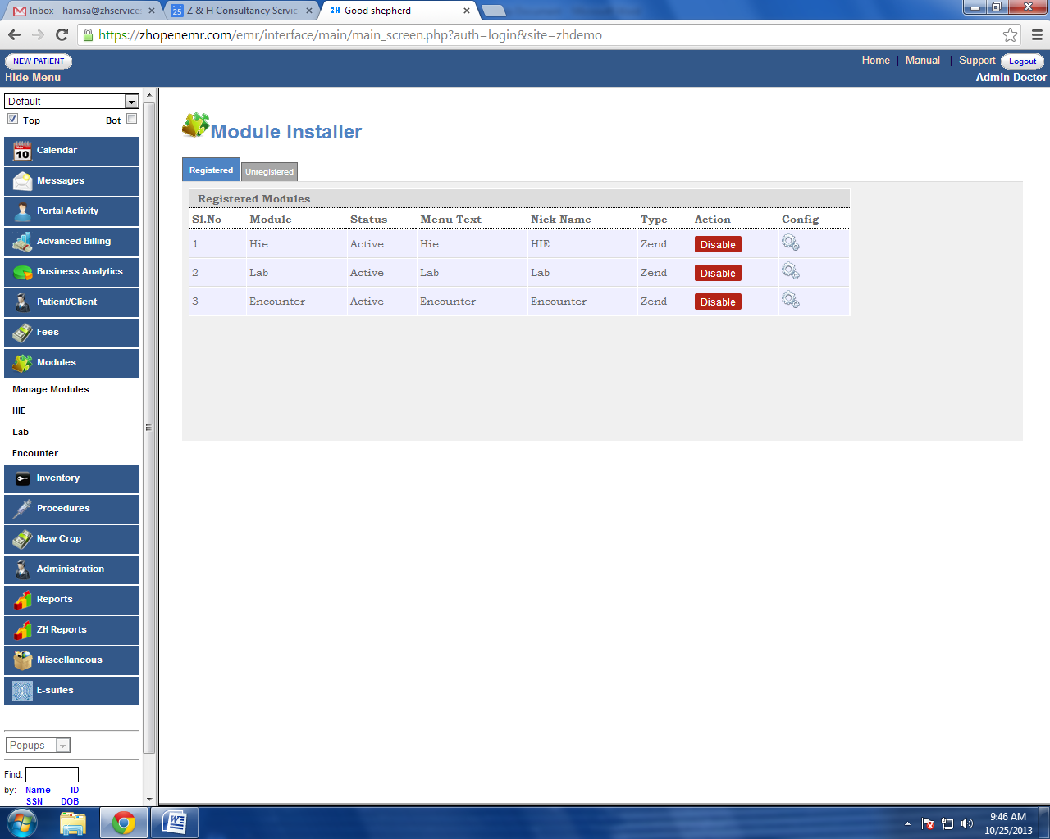

In the set-up panel, there are two tabs which shows the Registered and Unregistered modules. Initially the user has to click on the Unregistered tab to see the list of Modules in the system as there will be no registered Modules.

## Setting Up Modules using the Module Installer:

Below are the steps to follow to register and use the available modules.

Step1 : Click on unregistered tab to see the list of modules.

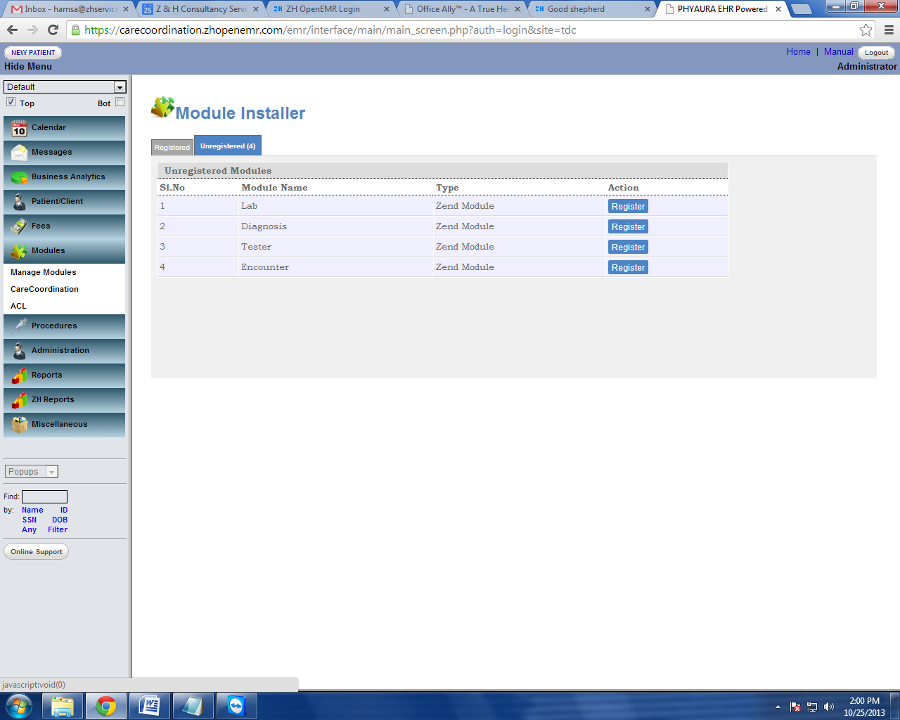

Step2 : Click on register button from the action column next to the module you would like register.

Step3 : Registered module will be listed in the registered tab as shown below.

For eg: When a “Lab” module is registered. It will be listed in the registered tab as shown below. The user can also give individual modules a nickname which will appear in the in the Left navigation menu. If the user chooses enters no nick name the Modules name itself will appear in the Left Navigation Menu

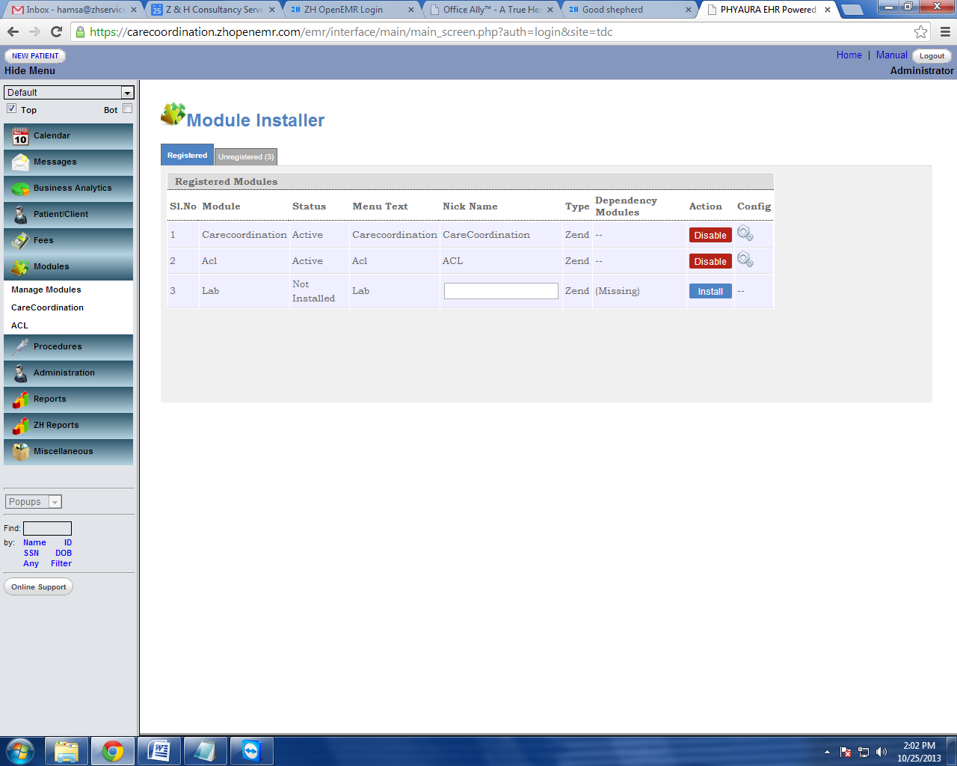

Step4 : Installing a Module from the registered tab.

Once a unregistered Module is registered a blue install button appears next to it. Click on the blue install button from the action column, which will install the module to your database. This action will show up the below screen for the next step.

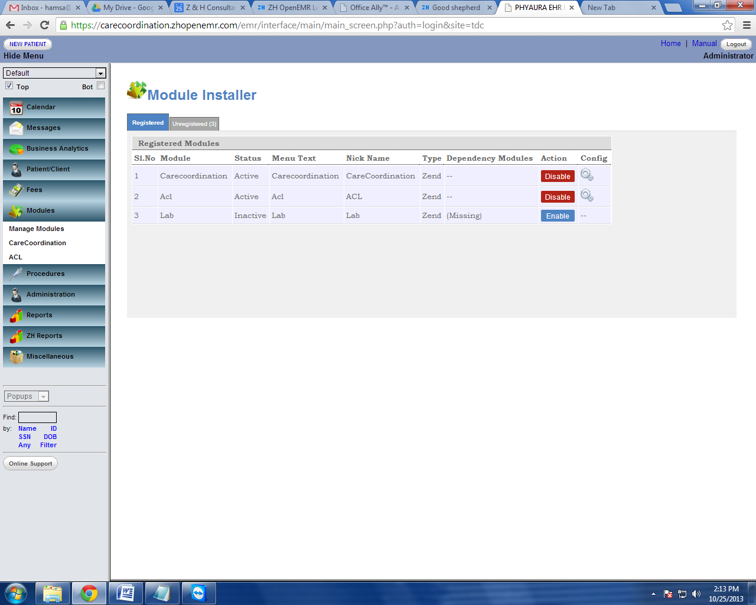

Step5 : Installed module has to be enabled using the Enable button from the action column.

Once the module is enabled, it will be listed in the modules in the left navigation menu as highlighted in the below screen,

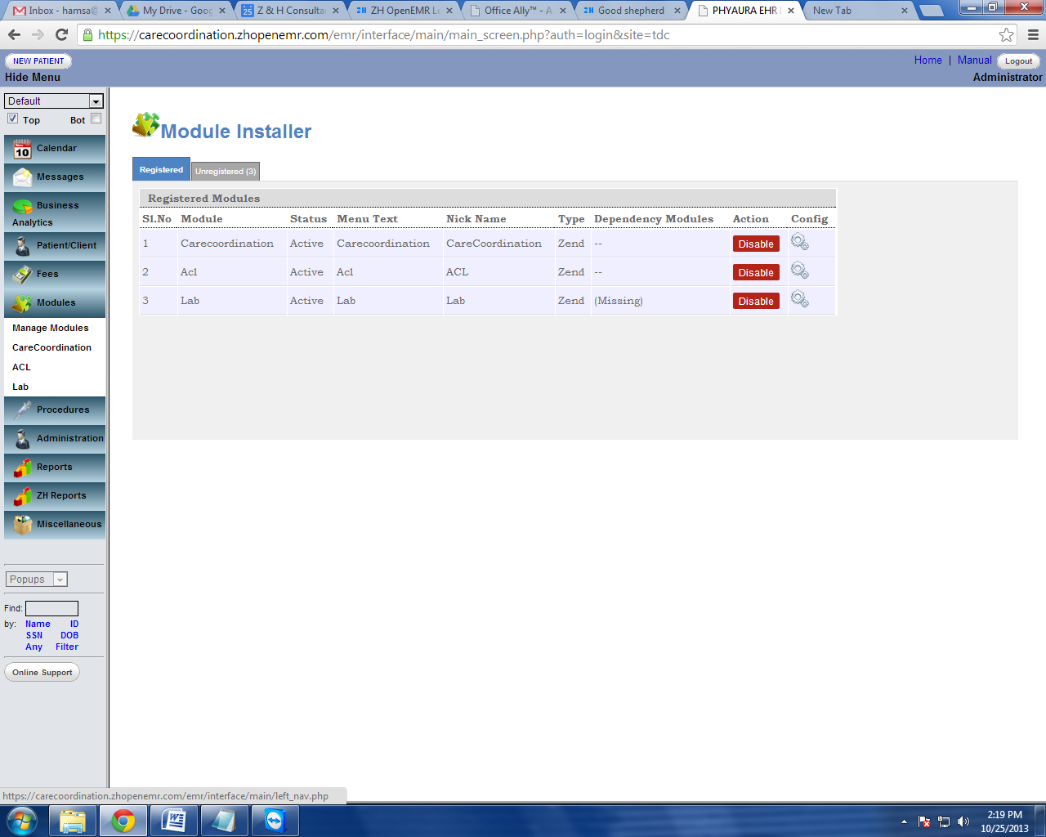

## Disabling a Enabled Module:

Inorder to disable a Module, the user can click on the Disable button show in the above screen shot.

# *Note : Although the system allows the user to disable the Module the data will remain in the database.*

# Configuration of Modules:

This section allows the user to configure access and dependencies of a module to different parts of the EMR.

To configure a module, Click on the settings symbol C:\Users\Hamza\Desktop\config.png shown next to the disable button in the above figure. This will show the configuration screen as shown below.

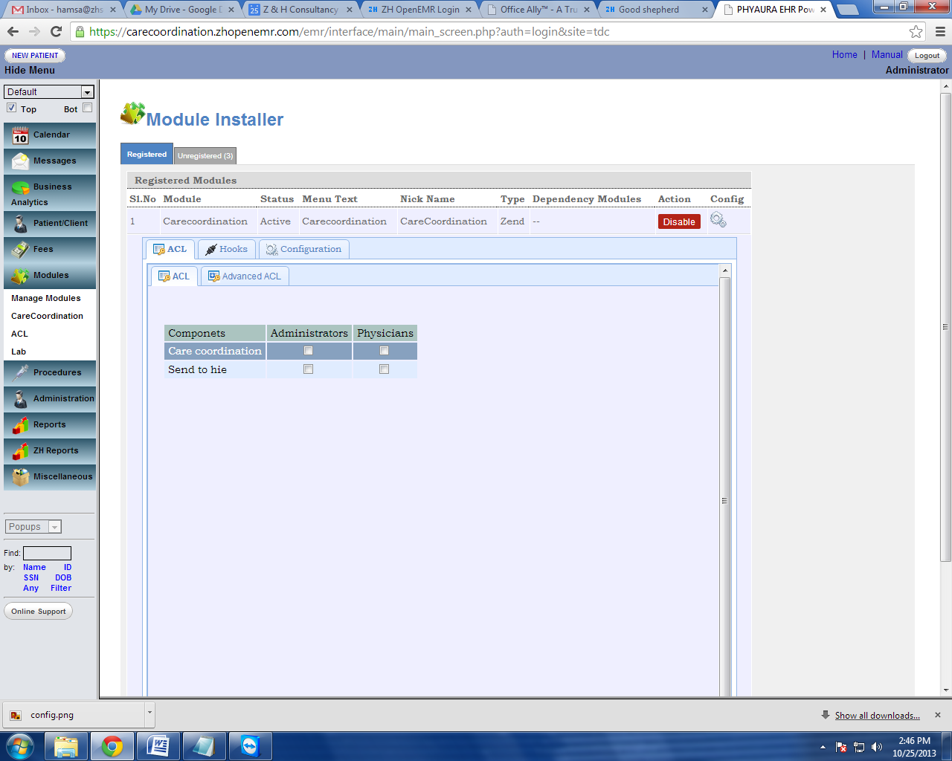

As shown above, the configuartion tab comprises of the below listed sub tabs.

1. Access Control
2. Hooks
3. Setting

These sub tabs are defined in more details

Note: *If you don’t see these tabs on your screen it means that EMR Adminstrator has not given you access right to configuration of the Modules.*

## Access Control:

This enables the user to define access rights to the Module. The Access Control Tab is divided into two sub tabs namely General and Advanced. As the name suggests the General Tab allows to define access from a User Group prepective while the advanced allows more granular definitions not only by user groups but by individual users also

These tabs are highlighted in the below Screen shot

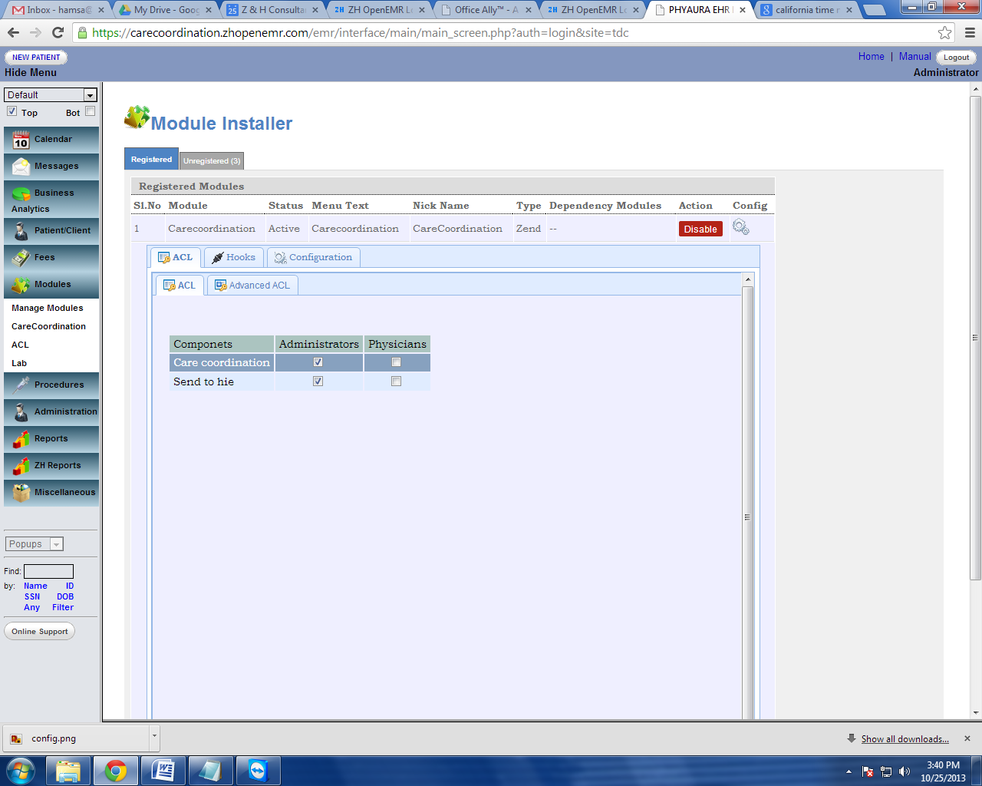

The below screen shows the Genral Tab selected. Here Administrators and Physicians are two User Groups defined in the EMR. Care Cordination is the main Module and Send to HIE is a component under Care Coordination Module. The checks boxes define the access right to these components. In the below example, Administrator have access to the entire Care Cordination Module while the Physician Group does not.

The user can also define access to only sub components from this window.

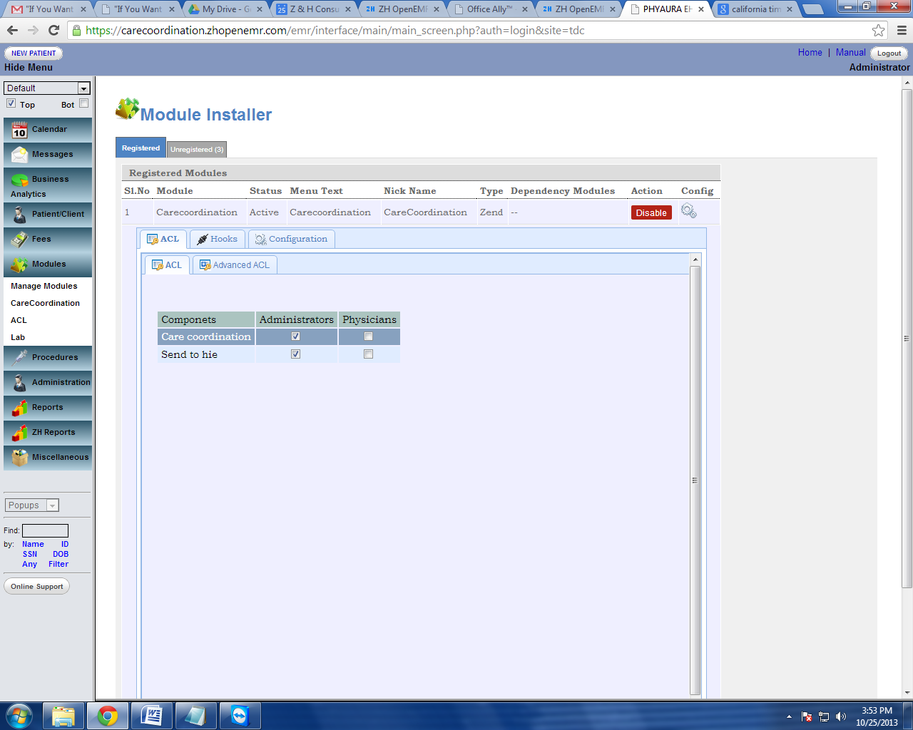

Advanced ACL:

This tab is used to access control for specific users. Even though the above step denied the access for a group, This section helps the administrator to give access for a specific user under the restricted group or in other words over ride the group access controls and define more specific access controls per user.

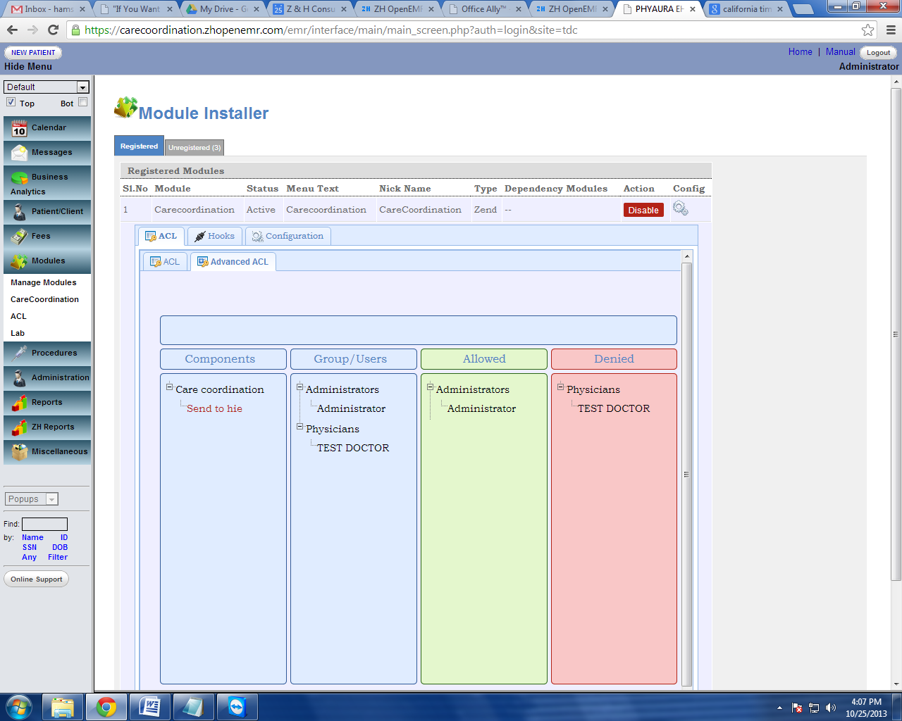

### Using the Advanced Tab:

The adavanced Tab is Drag/Drop enabled. In the above screen inorder to deny access only to User 1 - First Click on the the module form the Component section and then Drag User 1 and Drop the user into the the denied region.

Once done the screen will look as shown above.

Note: *The information is automatically saved as soon the user Drags and Drops the icons*

## Hook Management:

This sections enables the user to connect sub components as Hooks to different part of the of the EMR. For examlple in the above screen Reports, Encounters, Demographics and Combined forms are  parts of the encounter where the Send To HIE component can be placed thus connecting the Component of the Module to the EMR.

As shown above the check box defines where all the Hook needs to be deployed in the system

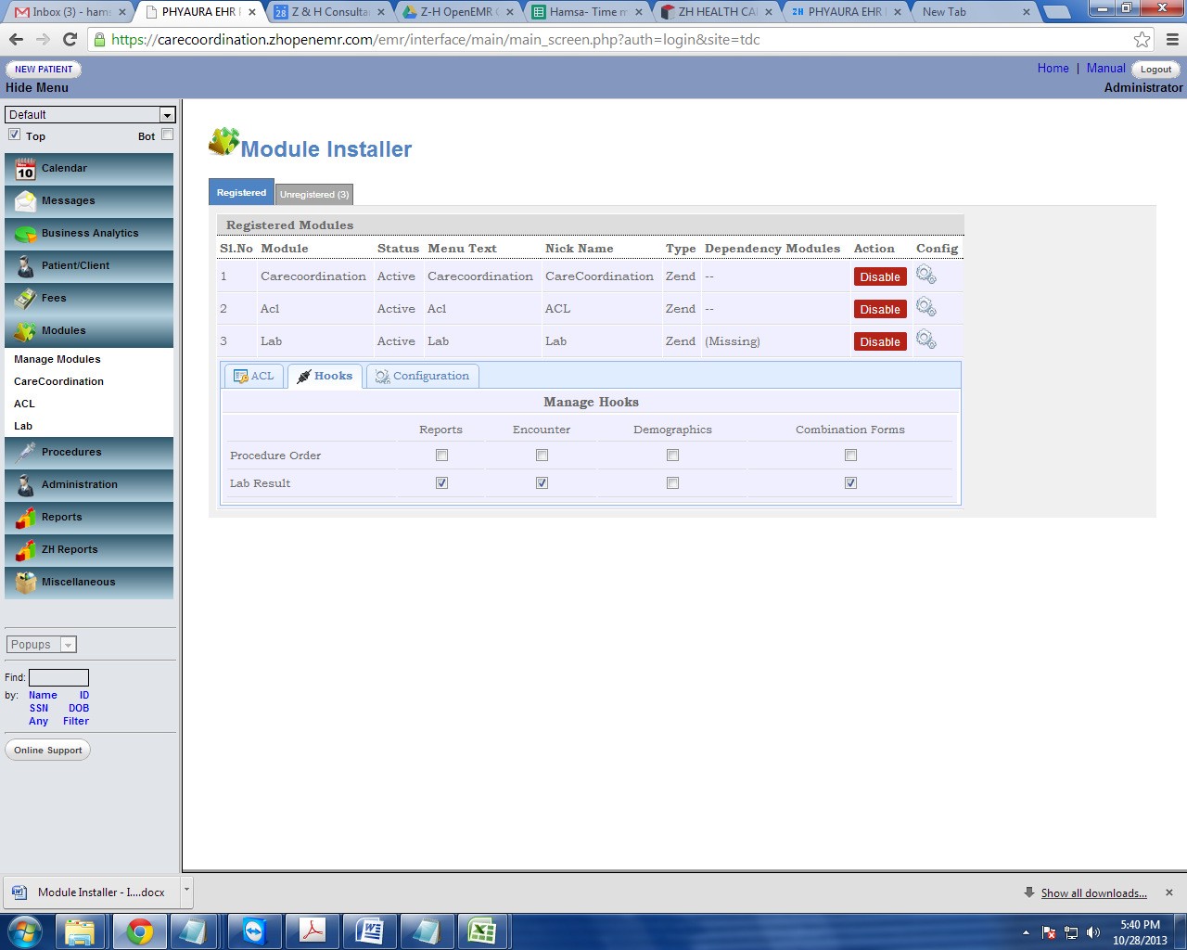

For Ex: Here “Lab results” hooked with Reports, Encounter, Demographics and Combination Forms.

Below screen shot shows how the “Lab Results” is hooked with in the Encounter, which is highlighted in red circle as shown below.

